Linux Mint
MY PLACES
Sign In

COMMUNITY
Ideas
Tutorials
Software
Hardware
Users
Moderation
Chat Room

BETA TESTING
ISO Images
Teams

Android Studio 3 on Linux Mint 18.3 Cinnamon
 | 2 years ago  -1
  
  tboxmy

Howto install Android Studio on Linux Mint 18.3.
The installed environment
System: Kernel: 4.10.0-38-generic x86_64 (64 bit)
Desktop: Cinnamon 3.6.7 Distro: Linux Mint 18.3 Sylvia
CPU: Dual core Intel Core i3-6100U (-HT-MCP-) speed/max: 499/2300 MHz
Graphics: Card-1: Intel Sky Lake Integrated Graphics
Card-2: NVIDIA Device 134f
Display Server: X.Org 1.18.4 driver: nvidia
Resolution: 1366x768@59.99hz
GLX Renderer: GeForce 920MX/PCIe/SSE2
GLX Version: 4.5.0 NVIDIA 384.111

Open a terminal.

Step 1. Install Java
$ sudo apt install openjdk-8-jdk openjdk-8-doc
$ javac -version
javac 1.8.0_151

Step 2. Install Android Studio
Download Android Studio Pack from official site, the link http://developer.android.com/sdk/index.html
$ sudo apt-get install libc6:i386 libncurses5:i386 libstdc++6:i386 lib32z1 libbz2-1.0:i386
$ cd Download
$ unzip android-studio-ide-171.4443003-linux.zip
$ sudo mv android-studio /opt
$ sudo chown -R root.root /opt/android-studio/

Step 3. Setup Android Studio for user
$ /opt/android-studio/bin/studio.sh
Android Studio installs the development SDK in the user's home folder.
Follow the instructions to complete installation to user's home folder (in /home/
My default Android applications target Marshmallow Android 6.0 (API 23). Before creating the first Android Studio Project, choose Settings. Select SDK Platforms -> Android 6.0. Choose Apply ->OK.
Done!
Next step? Create an Android Studio project and install the required libraries.

 | 2 years ago  -1
  tboxmy

Howto install Android Studio on Linux Mint 18.3.
The installed environment
System: Kernel: 4.10.0-38-generic x86_64 (64 bit)
Desktop: Cinnamon 3.6.7 Distro: Linux Mint 18.3 Sylvia
CPU: Dual core Intel Core i3-6100U (-HT-MCP-) speed/max: 499/2300 MHz
Graphics: Card-1: Intel Sky Lake Integrated Graphics
Card-2: NVIDIA Device 134f
Display Server: X.Org 1.18.4 driver: nvidia
Resolution: 1366x768@59.99hz
GLX Renderer: GeForce 920MX/PCIe/SSE2
GLX Version: 4.5.0 NVIDIA 384.111

Open a terminal.

Step 1. Install Java
$ sudo apt install openjdk-8-jdk openjdk-8-doc
$ javac -version
javac 1.8.0_151

Step 2. Install Android Studio
Download Android Studio Pack from official site, the link http://developer.android.com/sdk/index.html
$ sudo apt-get install libc6:i386 libncurses5:i386 libstdc++6:i386 lib32z1 libbz2-1.0:i386
$ cd Download
$ unzip android-studio-ide-171.4443003-linux.zip
$ sudo mv android-studio /opt
$ sudo chown -R root.root /opt/android-studio/

Step

Prerequisites
Check whether your CPU supports Intel VT / AMD SVM or not.
egrep --color 'vmx|svm' /proc/cpuinfo | wc -l
Output:
4
If the above output is non-zero, then your machine has Intel or AMD virtualization support.

Install KVM and other utilities
sudo apt install -y qemu-kvm libvirt-bin ubuntu-vm-builder bridge-utils wget unzip
Add your user to the KVM group.
sudo usermod -aG kvm raj
sudo usermod -aG libvirt raj
Reboot the machine or Log out and log in back.

Install 32-bit libraries
Use the apt command install 32-bit libraries.
sudo apt update

sudo apt install -y libc6:i386 libncurses5:i386 libstdc++6:i386 lib32z1 libbz2-1.0:i386 wget

Install Java
Android Studio requires Oracle JDK 8 (not OpenJDK) to function correctly.
First, add Oracle JDK repository on the system.
sudo add-apt-repository ppa:webupd8team/java
Then, install the Oracle JDK 8 using the following command.
sudo apt update

sudo apt install -y oracle-java8-installer

sudo apt install -y oracle-java8-set-default
During the Oracle JAVA installation, you would need to accept the Oracle License agreement
Check the java version
java -version
Output:
java version "1.8.0_181"
Java(TM) SE Runtime Environment (build 1.8.0_181-b13)
Java HotSpot(TM) 64-Bit Server VM (build 25.181-b13, mixed mode)

Install Android Studio on Linux Mint 19
Use the given link to download the latest version of Android Studio (Recommended Method).

Download Android Studio
OR
From terminal.
cd Downloads/

wget https://dl.google.com/dl/android/studio/ide-zips/3.1.3.0/android-studio-ide-173.4819257-linux.zip
Move the downloaded archive to /opt or to your desired directory and extract it there using the unzip command.
sudo mv android-studio-ide-*-linux.zip /opt/

cd /opt/

sudo unzip /opt/android-studio-ide-*-linux.zip
Change the permission of extracted files.
sudo chown -R raj:raj android-studio
Start the Android Studio by executing studio.sh from the bin directory.
cd /opt/android-studio/bin/

./studio.sh
Symlink the executable to /bin directory so that you can quickly start Android Studio using android-studio command irrespective of the current working directory.
sudo ln -sf /opt/android-studio/bin/studio.sh /bin/android-studio

Create Android Studio Launcher Icon on Linux Mint 19

Manual
To have Android Studio launcher icon in GNOME or Dash just like in the Start menu of Windows. Create a .desktop file under /usr/share/applications directory.
sudo nano /usr/share/applications/android-studio.desktop
Use the following information in the above file.
[Desktop Entry]
Version=1.0
Type=Application
Name=Android Studio
Comment=Android Studio
Exec=bash -i "/opt/android-studio/bin/studio.sh" %f
Icon=/opt/android-studio/bin/studio.png
Categories=Programming;Development
Terminal=false
StartupNotify=true
StartupWMClass=jetbrains-android-studio
Name[en_GB]=android-studio.desktop

Automatic (After you start Android Studio)
To make Android Studio available in your list of applications, select Tools >> Create Desktop Entry from the Android Studio menu bar.

Access Android Studio
You can start Android Studio by going to Menu >> Programming >> Android Studio.
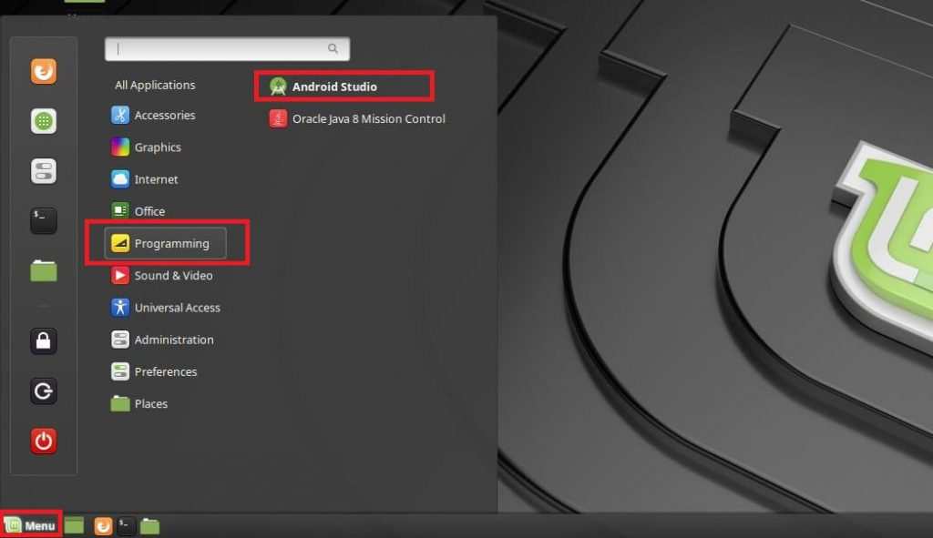 3. Setup Android Studio for user
$ /opt/android-studio/bin/studio.sh
Android Studio installs the development SDK in the user's home folder.
Follow the instructions to complete installation to user's home folder (in /home/
My default Android applications target Marshmallow Android 6.0 (API 23). Before creating the first Android Studio Project, choose Settings. Select SDK Platforms -> Android 6.0. Choose Apply ->OK.
Done!
Next step? Create an Android Studio project and install the required libraries.

Prerequisites
Check whether your CPU supports Intel VT / AMD SVM or not.
egrep --color 'vmx|svm' /proc/cpuinfo | wc -l
Output:
4
If the above output is non-zero, then your machine has Intel or AMD virtualization support.

Install KVM and other utilities
sudo apt install -y qemu-kvm libvirt-bin ubuntu-vm-builder bridge-utils wget unzip
Add your user to the KVM group.
sudo usermod -aG kvm raj
sudo usermod -aG libvirt raj
Reboot the machine or Log out and log in back.

Install 32-bit libraries
Use the apt command install 32-bit libraries.
sudo apt update

sudo apt install -y libc6:i386 libncurses5:i386 libstdc++6:i386 lib32z1 libbz2-1.0:i386 wget

Install Java
Android Studio requires Oracle JDK 8 (not OpenJDK) to function correctly.
First, add Oracle JDK repository on the system.
sudo add-apt-repository ppa:webupd8team/java
Then, install the Oracle JDK 8 using the following command.
sudo apt update

sudo apt install -y oracle-java8-installer

sudo apt install -y oracle-java8-set-default
During the Oracle JAVA installation, you would need to accept the Oracle License agreement
Check the java version
java -version
Output:
java version "1.8.0_181"
Java(TM) SE Runtime Environment (build 1.8.0_181-b13)
Java HotSpot(TM) 64-Bit Server VM (build 25.181-b13, mixed mode)

Install Android Studio on Linux Mint 19
Use the given link to download the latest version of Android Studio (Recommended Method).

Download Android Studio
OR
From terminal.
cd Downloads/

wget https://dl.google.com/dl/android/studio/ide-zips/3.1.3.0/android-studio-ide-173.4819257-linux.zip
Move the downloaded archive to /opt or to your desired directory and extract it there using the unzip command.
sudo mv android-studio-ide-*-linux.zip /opt/

cd /opt/

sudo unzip /opt/android-studio-ide-*-linux.zip
Change the permission of extracted files.
sudo chown -R raj:raj android-studio
Start the Android Studio by executing studio.sh from the bin directory.
cd /opt/android-studio/bin/

./studio.sh
Symlink the executable to /bin directory so that you can quickly start Android Studio using android-studio command irrespective of the current working directory.
sudo ln -sf /opt/android-studio/bin/studio.sh /bin/android-studio

Create Android Studio Launcher Icon on Linux Mint 19

Manual
To have Android Studio launcher icon in GNOME or Dash just like in the Start menu of Windows. Create a .desktop file under /usr/share/applications directory.
sudo nano /usr/share/applications/android-studio.desktop
Use the following information in the above file.
[Desktop Entry]
Version=1.0
Type=Application
Name=Android Studio
Comment=Android Studio
Exec=bash -i "/opt/android-studio/bin/studio.sh" %f
Icon=/opt/android-studio/bin/studio.png
Categories=Programming;Development
Terminal=false
StartupNotify=true
StartupWMClass=jetbrains-android-studio
Name[en_GB]=android-studio.desktop

Automatic (After you start Android Studio)
To make Android Studio available in your list of applications, select Tools >> Create Desktop Entry from the Android Studio menu bar.

Access Android Studio
You can start Android Studio by going to Menu >> Programming >> Android Studio.

